**ANALYTICS APIs AND TOOLs**

# Upgrading Google Analytics

## Course Introduction

## Upgrading from Legacy Page Tracking

## Upgrading Google Tag Manager

# Google Analytics APIs and tools

## Interacting with analytics Programmatically

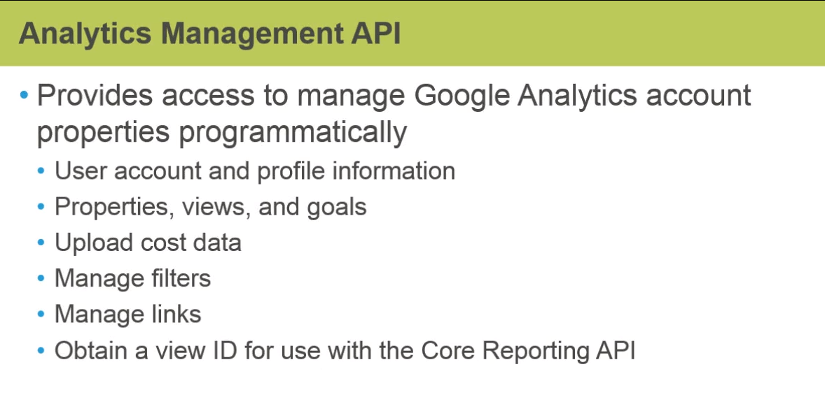

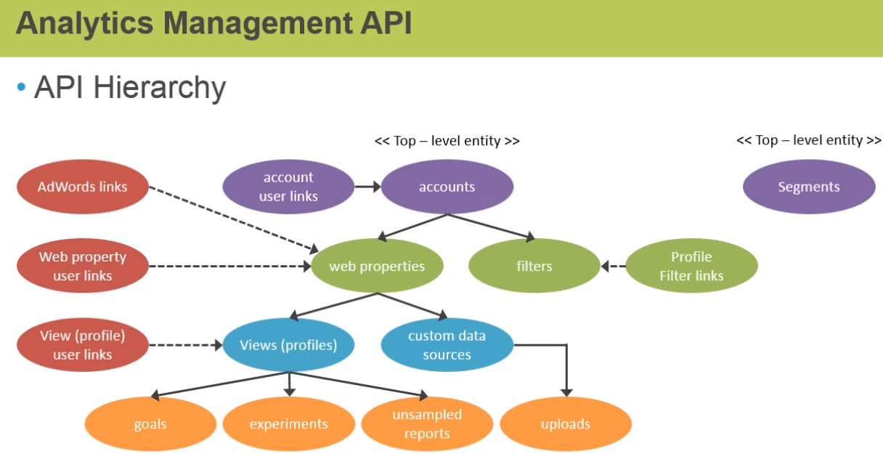

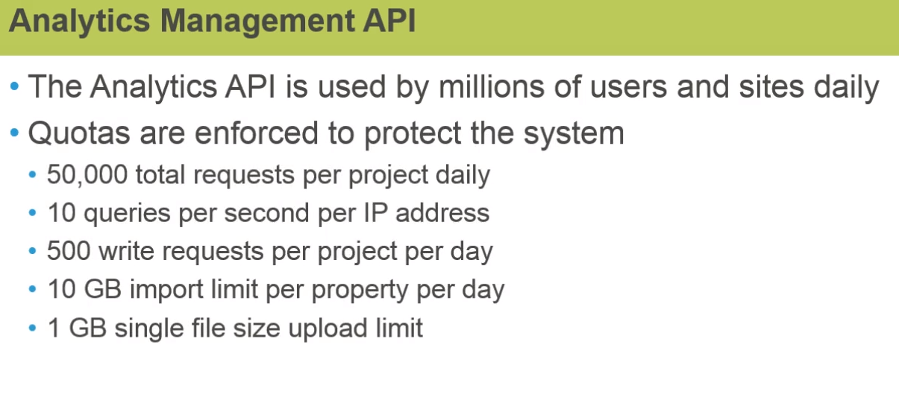

## Google Management API

## Introducting Core Reporting API

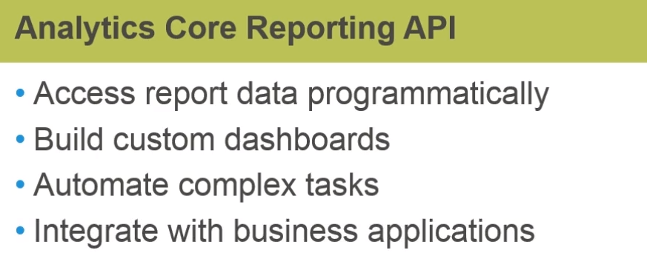

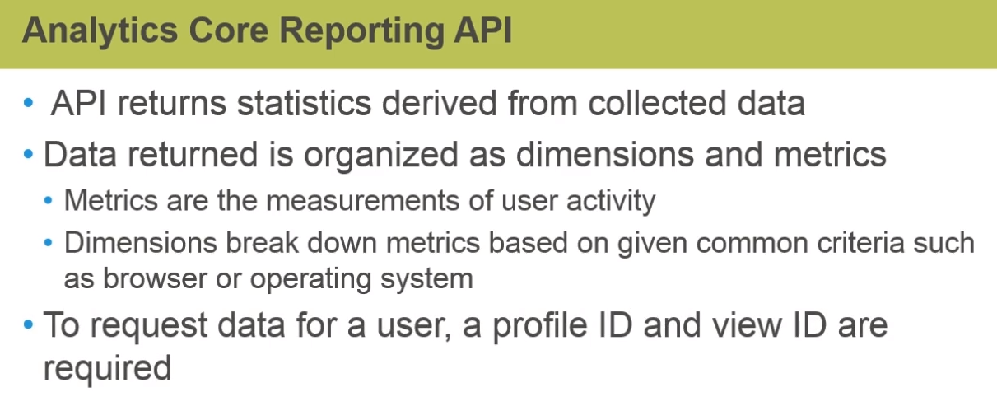

## Using the Query Explorer

## Goolge Analytics Spreadsheet Add-on

## Analytics Mobile App

# Practice : Use the Spreadsheet Add-on

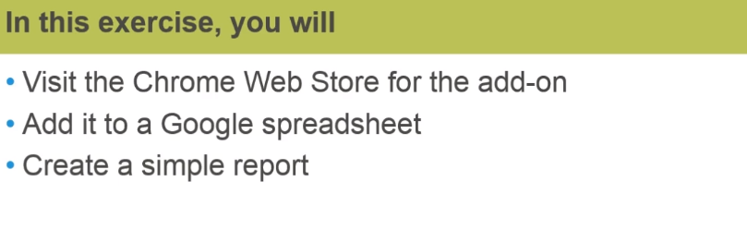

# Course Test